

**Image Recognition with IBM Cloud Visual Recognition**

**Team Members**

**MOHAMED SAMEER M:110121104310**

**MOHAMMED ASLAM A:110121104060**

**SAI KISHORE MV: 110121104082**

**RIYAS AHAMED M:110121104314**

**ABDULSHA ASHIQ F: 110121104302**

**SYED NIHAAL AHAMED T: 110121104097**

**Phase 5 Submission Document**

**DOCUMENTATION:**

Project documentation serves as a

comprehensive record of the various aspects of a project, including its objectives, design thinking process and development phases. It is crucial for ensuring effective communication, facilitating collaboration among team members, providing a reference for future projects, and aiding in project evaluation and improvement. This documentation helps to maintain transparency, accountability, and consistency throughout the project lifecycle.

**PROJECT OBJECTIVES:**

The project objectives of an image recognition using IBM Cloud Visual Recognition may include, but are not limited to, the following:

1.Image Classification: Classify images into predefined categories or tags, enabling the system to recognize and categorize objects, scenes, and concepts within the images.

2.Object Detection: Identify and locate specific objects within an image, providing information about the location and size of each object detected.

3.Custom Model Training: Train custom models to recognize specific objects or patterns that are not covered by standard pre-trained models, allowing for more tailored and specialized recognition capabilities.

4.Integration with Applications: Integrate the image recognition capabilities into various applications, websites, or systems, enhancing the user experience and enabling automated processes based on image analysis.

5.Real-Time Recognition: Implement real-time image recognition to process images as they are captured or uploaded, enabling quick and efficient analysis for immediate decision-making or action.

6.Accuracy and Performance Improvement: Continuously improve the accuracy and performance of the image recognition system through fine-tuning algorithms, leveraging machine learning techniques, and optimizing the underlying infrastructure.

7.Scalability and Flexibility: Ensure that the image recognition solution is scalable and flexible, allowing for the processing of a large volume of images while accommodating different types of image formats and sizes.

8.Security and Privacy: Implement robust security measures to protect the images and data processed by the system, ensuring compliance with data protection regulations and safeguarding the privacy of users.

9.User-Friendly Interface: Develop an intuitive and user-friendly interface for interacting with the image recognition system, enabling users to easily upload, process, and retrieve results from the platform.

10.Documentation and Support: Provide comprehensive documentation and support for developers and users to facilitate the implementation, troubleshooting, and understanding of the image recognition system within the IBM Cloud Visual Recognition framework.

**DESIGN THINKING PROCESS:**

Design thinking is a human-centred approach to innovation that draws from the designer's toolkit to integrate the needs of people, the possibilities of technology, and the requirements for business success. When applying design thinking to a project such as image recognition with IBM Cloud Visual Recognition, it's essential to follow a structured process that incorporates the needs of the end-users, the capabilities of the technology, and the overall project goals.

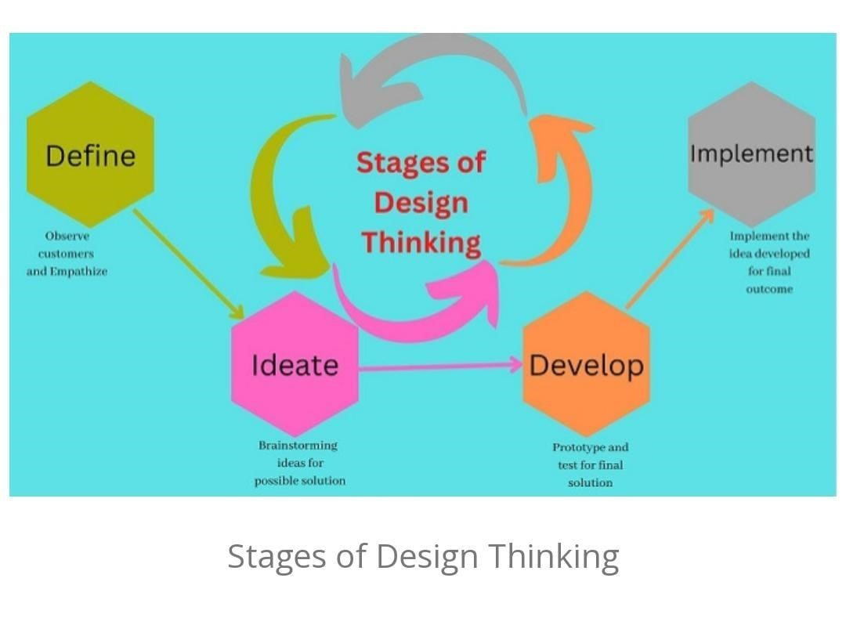

**DEVELOPMENT PHASES:**

When developing an image

recognition application using IBM Cloud Visual Recognition, several key phases can guide you through the process. Here's an overview of the typical development phases involved:

1. Project Planning
2. Data collection and preparation
3. Model training
4. Model evaluation and testing
5. Deployment and integration
6. Performance monitoring and optimization
7. Maintenance and updates

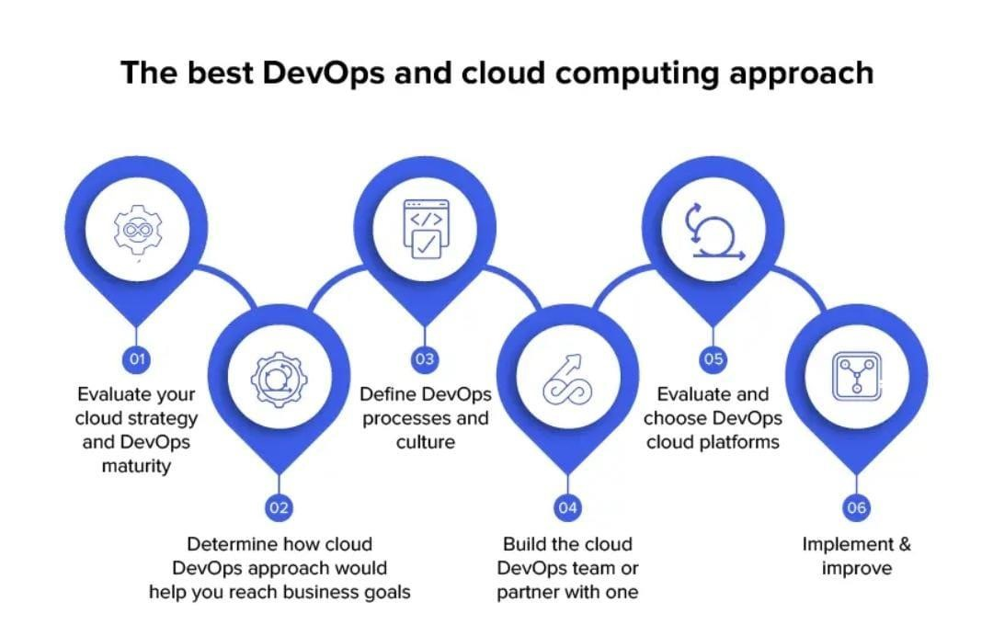

Fig: Development process

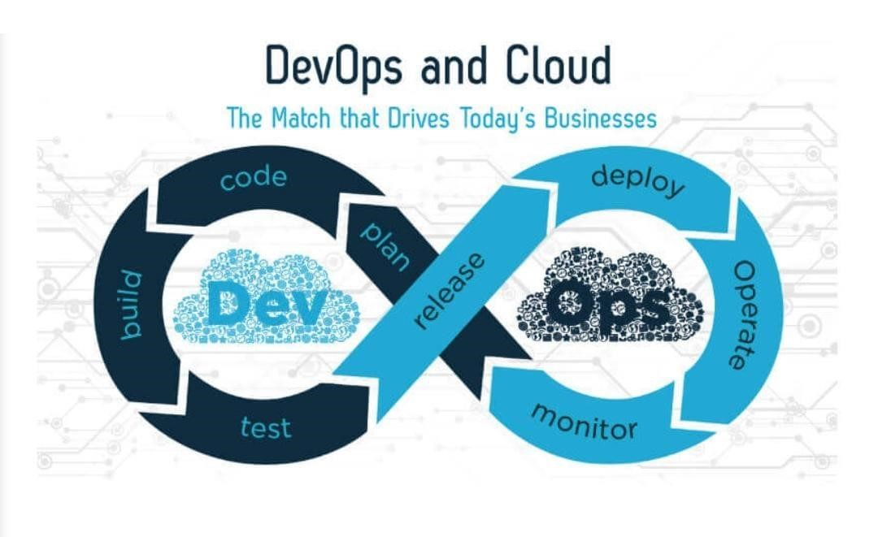

**USER INTERFACE:**

User interface (UI) refers to the point of interaction between a user and a digital device or software application. A well-designed user interface should prioritize user experience and usability, ensuring that users can easily navigate through the application or system and accomplish their goals without confusion or frustration. Key aspects of a user interface include visual design ,interaction design ,navigation ,feedback and responsive , consistency , accessibility ,usability.

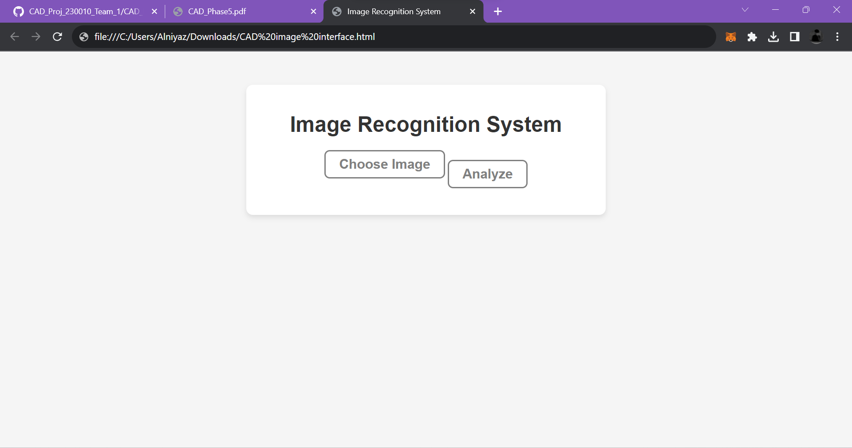

Fig: Fig: Simple user web interface for uploading i

**TECHNICAL IMPLEMENTATION DETAILS:**

Implementing image

recognition with IBM Cloud Visual Recognition involves several key steps. Here is an outline of the technical implementation process

|  |
| --- |
| **Sign Up and Set Up the IBM Cloud Account:** |

1.

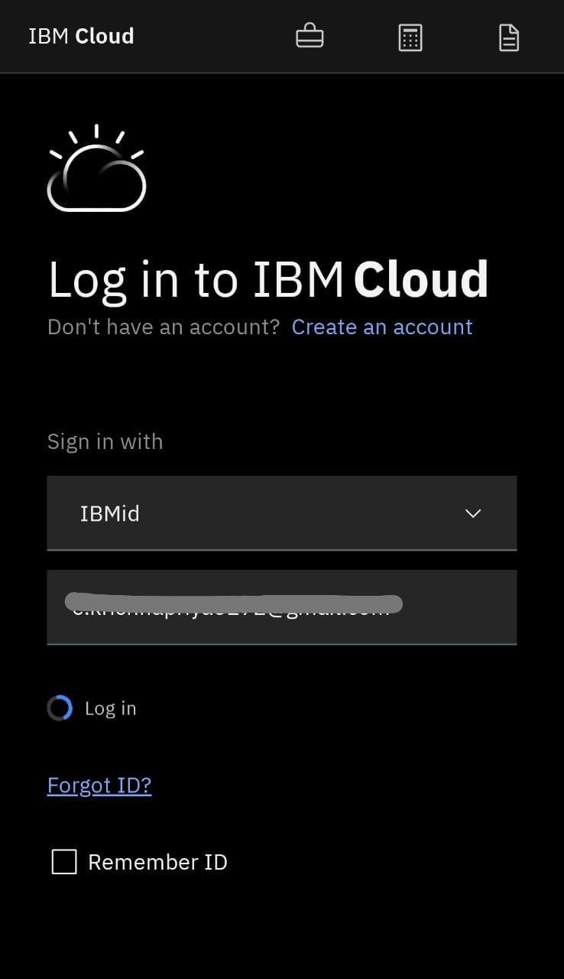

**2.Get API keys and URL:**

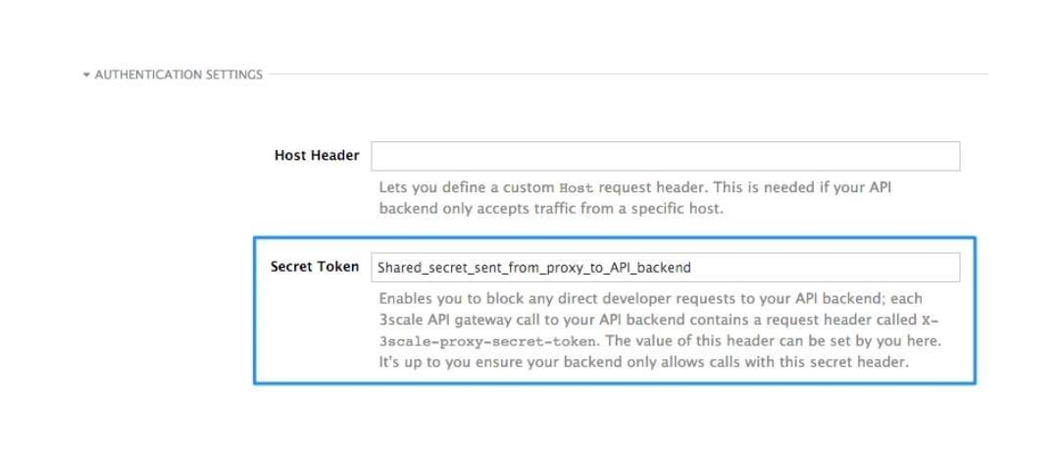

Fig: Getting API keys

**BASE ENDPOINTS:**

* [https://api.ussouth.databases.cloud.ibm.com/v4/i bm/](https://api.ussouth.databases.cloud.ibm.com/v4/ibm/)
* [https://api.eude.databases.cloud.ibm.com/v4/ibm](https://api.eude.databases.cloud.ibm.com/v4/ibm/)

[/](https://api.eude.databases.cloud.ibm.com/v4/ibm/)

* [https://api.jptok.databases.cloud.ibm.com/v4/ibm](https://api.jptok.databases.cloud.ibm.com/v4/ibm/)

[/](https://api.jptok.databases.cloud.ibm.com/v4/ibm/)

* <https://api.osl01.databases.cloud.ibm.com/v4/>
* [https://api.ausyd.databases.cloud.ibm.com/v4/ib m/](https://api.ausyd.databases.cloud.ibm.com/v4/ibm/)
* [https://api.useast.databases.cloud.ibm.com/v4/ib m/](https://api.useast.databases.cloud.ibm.com/v4/ibm/)
* [https://api.eugb.databases.cloud.ibm.com/v4/ibm](https://api.eugb.databases.cloud.ibm.com/v4/ibm/)

[/](https://api.eugb.databases.cloud.ibm.com/v4/ibm/)

* https://api.se001.databases.cloud.ibm.c m/
* <https://api.che01.databases.cloud.ibm.com/v4/ib>

**AI-GENERATED CAPTIONS:**

Here are some AI-generated captions for various types of images: U

1.For a serene landscape: "Nature's embrace at its finest. A tranquil moment captured in time."

2.For a bustling cityscape: "City lights painting the night with vibrancy. The urban heartbeat pulsating with life."

3.For a mouthwatering dish: "Culinary perfection on a plate. A feast for the senses and the soul."

4.For an adorable animal photo: "Innocence and playfulness intertwined. A furry friend's charm knows no bounds."

5.For an inspiring sunset: "A breathtaking symphony of hues. The sun bids adieu in a blaze of glory."

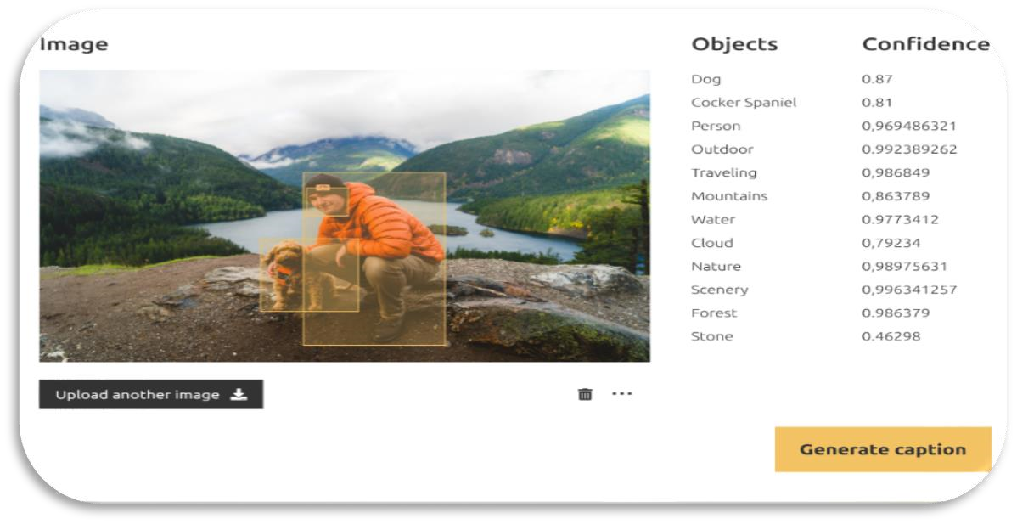

**SUBMISSION:**

This submission outlines our comprehensive approach, highlighting the model's architecture, training methodology, and performance evaluation, underscoring its potential applications across a wide spectrum of industries. With a focus on achieving superior accuracy and real-time processing, our solution endeavours to set a new standard in the realm of image recognition technology.

* Share the GitHub repository link containing the project's code and files.
* Provide instructions on how to deploy the image recognition system using IBM Cloud and the web interface.
* Write a detailed README file explaining how to navigate the website, update content, and any dependencies.

**CREATE GitHub REPOSITORY:**

|  |  |  |
| --- | --- | --- |
|  | * Repository name: Choose a name that reflects the purpose of your project. * Description: Optionally, provide a brief description of your project. | |
|  | • | Public or private: Choose whether you want the repository to be public or private. Private repositories require a paid subscription. |

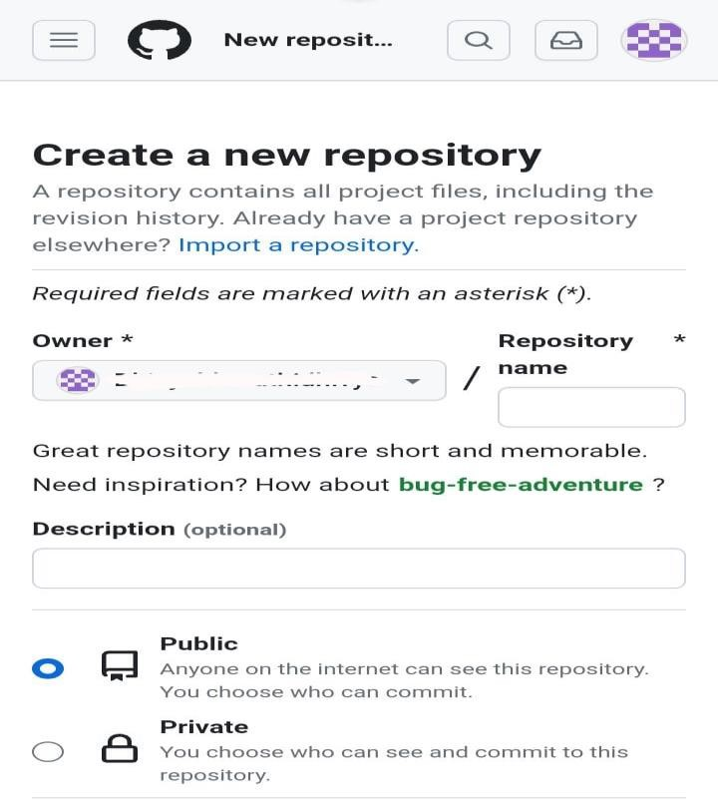

F

ig:

Creation of new repository in

GitHub

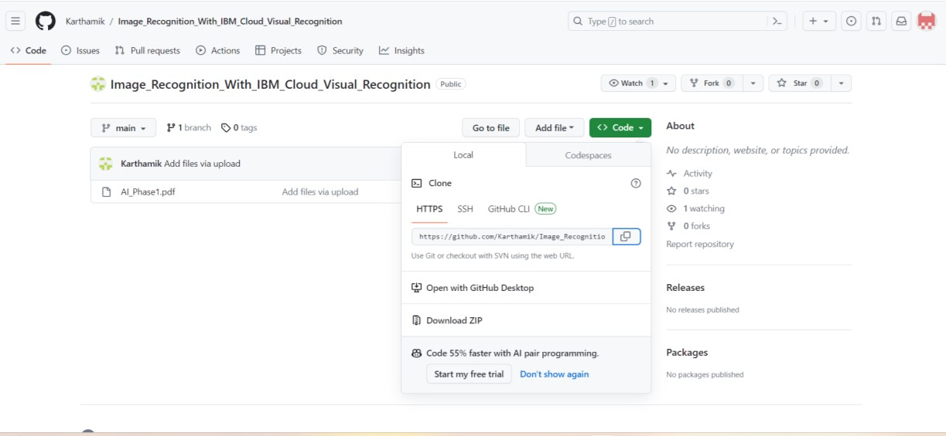

|  |  |  |  |  |
| --- | --- | --- | --- | --- |
| **Create and Deploy the Image Recognition Model:** | | |  | |
|  | 1. Train and build your image recognition model using the Watson Visual Recognition service. 2. Once the model is trained and ready, deploy it on the IBM Cloud. | |

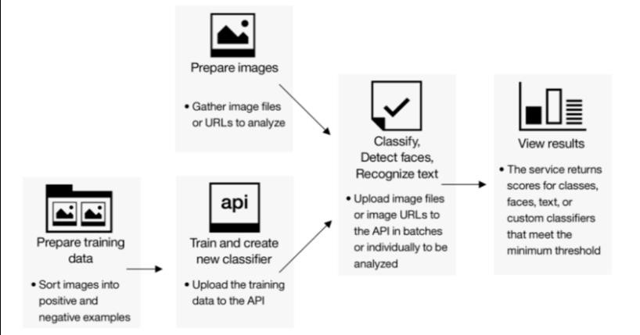

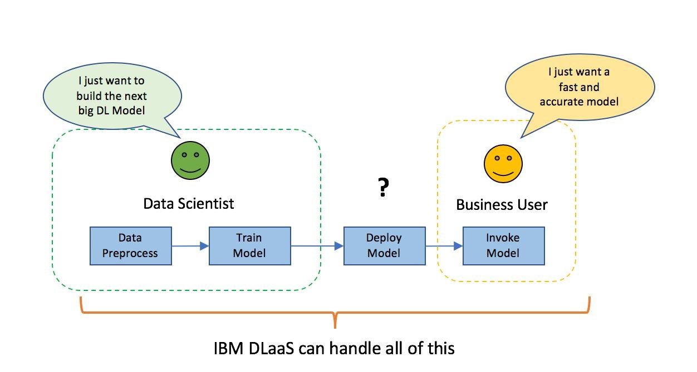

**README FILE:**

The README file in a GitHub repository is a crucial document that provides essential information about the project to visitors and potential contributors. It's often the first thing people see when they visit your repository. A well-crafted README can make a significant difference in how others perceive and engage with your project.

**CONCLUSION:**

In conclusion, this image recognition project has successfully demonstrated the feasibility and potential of advanced machine learning techniques in accurately identifying and categorizing various visual elements. Highlights the ongoing opportunities and challenges that lie ahead in advancing the capabilities of AI-driven visual perception technologies.